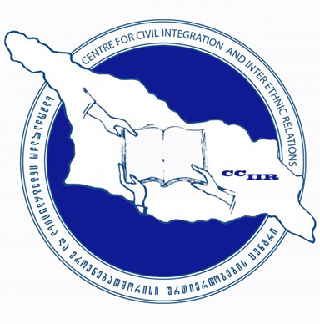
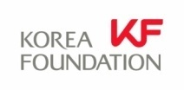

“Future Prospects of the Georgian-Korean Economic Cooperation”

18 April 2013
“Caucasian House”, The Center for Cultural Relations
Galaktion Tabidze st. 20, Tbilisi, Georgia

12:30 - 13:00 | Registration
13:00 - 13:20 | Opening remarks  - Natia Gorgadze – Head, Center for Civil Integration and Inter-Ethnic Relations (CCIIR)  - Kim Hoekil – Director, Moscow Office of the Korea Foundation
13:20 - 14:45 | Moderator:  Giuli Shabashvili – Associate Professor, Faculty of Humanities, Tbilisi State University (TSU)  Speakers:  - Vakhtang Kolbaia - Former Vice-Speaker of the Georgian Parliament, “The Korean Economic Model as an Opportunity for Deepening Georgian-Korean Cooperation”  - Kim Jaecheol – Counsellor, Embassy of the Republic of Korea to the Republic of Georgia (Residency: Azerbaijan), “The Economic Cooperation between Georgia and Korea”  - Giorgi Abashishvili - Deputy Dean, Head of Economic Research and Consulting Center, Iliauni Business School “Challenges of the new government - Future Prospects of the Georgian-Korean Economic Cooperation”  - Lee Yeonho – Professor, Department of Political Science and International Studies, Yonsei University, “Korean Economic Development and the Role of Government”  - Ketevan Gochitashvili - Professor, Faculty of Humanities, Tbilisi State University, "South Korea in Georgian Media"  - Besiki Lortkipanidze - Professor, Illia State University
14:45 - 15:00 | Questions and Answers  Discussion  Conclusion
15:00~ | Coffee/Tea

